banking_core | SBP
V1.0

Revision History
Version | Date | Description | Author
1.0 | 17/02/2026 | Initial Version | Mohammed Megahed

Reviewers
# | Name | Position | Date and Signature
1
2

Acceptance and Signoff
# | Name | Position | Date and Signature
1
2

Contents
1. Introduction 5
1.1. Project Summary 5
1.2. In-Scope 5
1.3. Out-Scope 5
1.4. Target Audience 5
1.5. Abbreviations 5
1.6. Assumptions, Dependencies and Risks 6
1.7. Impact Questionnaire 6
2. Requirements Compliancy Matrix 6
3. Solution Architecture 8
3.1. Solution Description 8
3.2. Non-Functional Requirements 8
3.3. Security Considerations 8
4. Account Opening Flow 9
4.1. Sequence Diagram 9
4.2. Flow Description 10
4.3. State Machine Diagram 13
4.4. APIs Contract Agreement 15
4.5. Error Handling 15
5. Instant Fund Transfer via SARIE 18
5.1. Sequence Diagram 18
5.2. Flow Description 19
5.3. State Machine Diagram 22
5.4. APIs Contract Agreement 24
5.5. Error Handling 25
6. Personal Loan Disbursement 27
6.1. Sequence Diagram 27
6.2. Flow Description 29
6.3. State Machine Diagram 31
6.4. APIs Contract Agreement 33
6.5. Error Handling 34
7. Appendix 38
7.1. Account Opening Flow Data Elements 38
7.2. Instant Fund Transfer via SARIE Data Elements 38
7.3. Personal Loan Disbursement Data Elements 40
7.4. Solution Architecture Reference Documents 41

1. Introduction

1.1. Project Summary
We are building a modern, cloud-native core banking system to replace legacy mainframe systems and address limitations in customer onboarding, account management, and transaction processing for both individual and corporate clients. The system supports real-time processing, multi-currency accounts, unified customer views, cash and fund transfers (including SARIE), and provides Open Banking APIs. This enables faster onboarding, improved customer experience, and operational efficiency for retail banking services.

1.2. In-Scope
# | Item
1. | Customer onboarding (individual and corporate)
2. | Account management (Current, Savings, Term Deposit)
3. | Cash deposits and withdrawals
4. | Internal fund transfers
5. | Domestic transfers via SARIE
6. | International transfers via SWIFT
7. | Personal loan origination and disbursement

1.3. Out-Scope
# | Item
1. | Credit card management
2. | Trade finance operations
3. | Treasury and investment banking
4. | Islamic banking products

1.4. Target Audience
# | Stakeholders
1. | Enterprise Architects
2. | Partners and Vendors Technical Leaders
3. | Infrastructure Architects & Engineers
4. | InfoSec Architects & Engineers
5. | Technical Managers
6. | Delivery Leads and Project Managers
7. | Developers

1.5. Abbreviations
# | Abbreviations | Full form
1
2
3

1.6. Assumptions, Dependencies and Risks
# | Item | Type | Owner | Comment
1.
2.

2. Requirements Compliancy Matrix
ID. | Title | Description | Compliancy | Comments
FR-1 | CoreBank is a modern core banking system replacing legacy mainframe systems with | CoreBank provides a modern core banking platform that replaces outdated mainframe systems, enabling improved efficiency, scalability, and support for current and future business needs. | Compliant
FR-2 | The platform supports retail banking operations including account management, de | The platform enables customers to manage accounts, make deposits, access lending services, and transfer funds to support comprehensive retail banking operations. | Compliant
FR-3 | Real-time processing and Open Banking APIs enable digital transformation | The business enables customers and partners to access financial data and services instantly through real-time processing and Open Banking APIs, supporting faster transactions, improved customer experiences, and new digital business opportunities. | Compliant
FR-BR-001 | Customer Onboarding | Customers complete a standardized onboarding process to verify their identity and eligibility before accessing products or services. This ensures compliance with regulatory requirements and supports a secure customer relationship. | Compliant
FR-BR-002 | View | Users can access a complete, unified view of all relevant customer information to support informed decision-making and efficient service. | Compliant
FR-BR-003 | Account Types | The organization offers defined account types to meet different customer needs and regulatory requirements. Each account type provides specific features, benefits, and eligibility criteria to ensure customers select the most appropriate option for their circumstances. | Compliant
FR-BR-004 | Multi-Currency | The solution supports transactions and reporting in multiple currencies, enabling users to conduct business and view financial information in their preferred currency. | Compliant
FR-BR-005 | Real-time Balance | Users can view their current account balance at any time, ensuring they have up-to-date information to make informed financial decisions. | Compliant
FR-BR-006 | ransfer | Enable users to transfer funds securely and efficiently through the SARIE payment system, ensuring timely and accurate processing of transactions. | Compliant
FR-BR-007 | ransfer | The business enables users to send and receive funds securely and efficiently through SWIFT transfers, supporting international payments in compliance with financial regulations. | Compliant
FR-BR-008 | Loan Origination | The loan origination process ensures that all loan applications are collected, reviewed, and approved according to established business policies and regulatory guidelines. This process enables customers to apply for loans efficiently and ensures that only eligible applicants receive loan approvals, supporting responsible lending practices and regulatory compliance. | Compliant
FR-BR-009 | alculation | The system calculates accurate Equated Monthly Installment (EMI) amounts for users based on loan details, ensuring clarity and transparency in repayment information. | Compliant
FR-BR-010 | osting | Ensure all financial transactions are accurately recorded in the general ledger to support transparent financial reporting and compliance with accounting standards. | Compliant

3. Solution Architecture

3.1. Solution Description
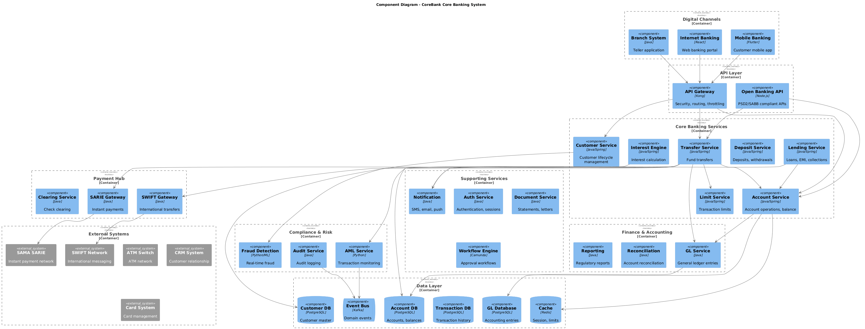

3.2. Non-Functional Requirements
# | Category | Requirement | Target/SLA
1 | Performance | API Response Time | < 2 seconds for 95th percentile
2 | Performance | Transaction Throughput | Support 100 TPS during peak hours
3 | Availability | System Uptime | 99.9% availability (excluding planned maintenance)
4 | Availability | Recovery Time Objective (RTO) | < 4 hours
5 | Availability | Recovery Point Objective (RPO) | < 1 hour
6 | Scalability | Horizontal Scaling | Support auto-scaling based on load
7 | Scalability | Concurrent Users | Support 1000 concurrent users
8 | Data Retention | Transaction Logs | Retain for 7 years as per regulatory requirements
9 | Data Retention | Audit Logs | Retain for 5 years
10 | Compliance | Regulatory | Comply with CMA and SAMA regulations
11 | Compliance | Data Protection | Comply with data privacy requirements

3.3. Security Considerations
# | Security Domain | Requirement | Implementation
1 | Authentication | User Authentication | OAuth 2.0 / JWT tokens with secure token storage
2 | Authentication | Service-to-Service Auth | Mutual TLS (mTLS) for internal service communication
3 | Authentication | Multi-Factor Authentication | MFA required for sensitive operations
4 | Authorization | Role-Based Access Control | RBAC implemented with principle of least privilege
5 | Authorization | API Authorization | Scope-based access control for API endpoints
6 | Data Protection | Data in Transit | TLS 1.2+ encryption for all network communication
7 | Data Protection | Data at Rest | AES-256 encryption for sensitive data storage
8 | Data Protection | PII/Sensitive Data | Data masking and tokenization for sensitive fields
9 | API Security | Input Validation | Server-side validation of all input parameters
10 | API Security | Rate Limiting | Rate limiting to prevent abuse and DDoS attacks
11 | API Security | CORS Policy | Strict CORS policy for web API endpoints
12 | Audit & Logging | Audit Trail | Log all security-relevant events with timestamps
13 | Audit & Logging | Log Protection | Immutable logs with tamper detection
14 | Vulnerability Management | Security Scanning | Regular SAST/DAST scanning in CI/CD pipeline
15 | Vulnerability Management | Dependency Scanning | Automated scanning for vulnerable dependencies

4. Account Opening Flow

4.1. Sequence Diagram
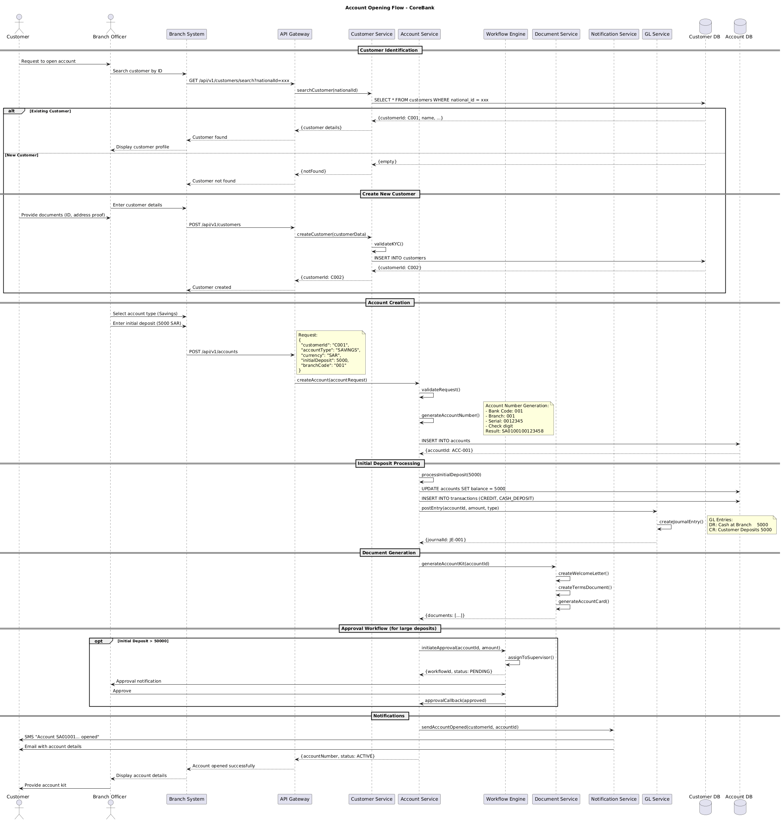

4.2. Flow Description
  - Overview
This flow describes the end-to-end process for opening a new account in the CoreBank system, involving customer identification, account creation, initial deposit handling, document generation, approval workflow for large deposits, and customer notifications. The main actors and systems involved are Customer, Branch Officer, Branch System, API Gateway, Customer Service, Account Service, Workflow Engine, Document Service, Notification Service, GL Service, Customer DB, and Account DB. Each participant is responsible for specific interactions and internal processing steps as detailed below.
  - Process Flow
Customer Identification
The process begins when Customer requests to open an account with Branch Officer. Branch Officer initiates a customer search in Branch System by providing the customer's national ID. Branch System forwards this request to API Gateway, which then calls Customer Service to search for the customer using the provided national ID. Customer Service queries Customer DB for a matching record.
If the customer already exists, Customer DB returns the customer details to Customer Service, which forwards them to API Gateway. API Gateway notifies Branch System that the customer was found, and Branch System instructs Branch Officer to display the customer profile.
If the customer does not exist, Customer DB returns an empty result to Customer Service, which notifies API Gateway that the customer was not found. API Gateway informs Branch System, which then proceeds with the new customer onboarding process.
Create New Customer
When a new customer is identified, Branch Officer enters the customer's details into Branch System. Customer provides the required documents, such as ID and address proof, to Branch Officer. Branch System sends a request to API Gateway to create the new customer. API Gateway calls Customer Service to create the customer with the provided data. Customer Service internally performs an operation to validateKYC(). Customer Service inserts the new customer record into Customer DB. Customer DB returns the newly created customer ID to Customer Service, which then passes it back to API Gateway. API Gateway informs Branch System that the customer has been created.
Account Creation
Branch Officer selects the account type and enters the initial deposit amount (e.g., 5000 SAR) in Branch System. Branch System sends a request to API Gateway to create the account.
Note: Request:
{
"customerId": "C001",
"accountType": "SAVINGS",
"currency": "SAR",
"initialDeposit": 5000,
"branchCode": "001"
}
API Gateway forwards the account creation request to Account Service. Account Service internally performs an operation to validateRequest(). Account Service internally performs an operation to generateAccountNumber().
Note: Account Number Generation:
- Bank Code: 001
- Branch: 001
- Serial: 0012345
- Check digit
Result: SA0100100123458
Account Service inserts the new account record into Account DB. Account DB returns the account ID to Account Service.
Initial Deposit Processing
Account Service internally performs an operation to processInitialDeposit(5000). Account Service updates the account balance in Account DB and inserts a transaction record for the cash deposit. Account Service sends a request to GL Service to post the corresponding general ledger entry. GL Service internally performs an operation to createJournalEntry().
Note: GL Entries:
DR: Cash at Branch 5000
CR: Customer Deposits 5000
GL Service returns the journal entry ID to Account Service.
Document Generation
Account Service requests Document Service to generate the account kit for the new account. Document Service internally performs an operation to createWelcomeLetter(). Document Service internally performs an operation to createTermsDocument(). Document Service internally performs an operation to generateAccountCard(). Document Service returns the generated documents to Account Service.
Approval Workflow (for large deposits)
Optionally, if the initial deposit exceeds 50,000, Account Service initiates an approval workflow with Workflow Engine by providing the account ID and deposit amount. Workflow Engine internally performs an operation to assignToSupervisor(). Workflow Engine returns the workflow ID and a pending status to Account Service. Workflow Engine notifies Branch Officer for approval. Branch Officer approves the request, and Workflow Engine sends an approval callback to Account Service.
Notifications
Account Service instructs Notification Service to send account opening notifications to the customer. Notification Service sends an SMS to Customer indicating that the account has been opened. Notification Service also sends an email to Customer with the account details. Account Service returns the account number and active status to API Gateway. API Gateway notifies Branch System that the account has been opened successfully. Branch System instructs Branch Officer to display the account details. Finally, Branch Officer provides the account kit to Customer.

4.3. State Machine Diagram
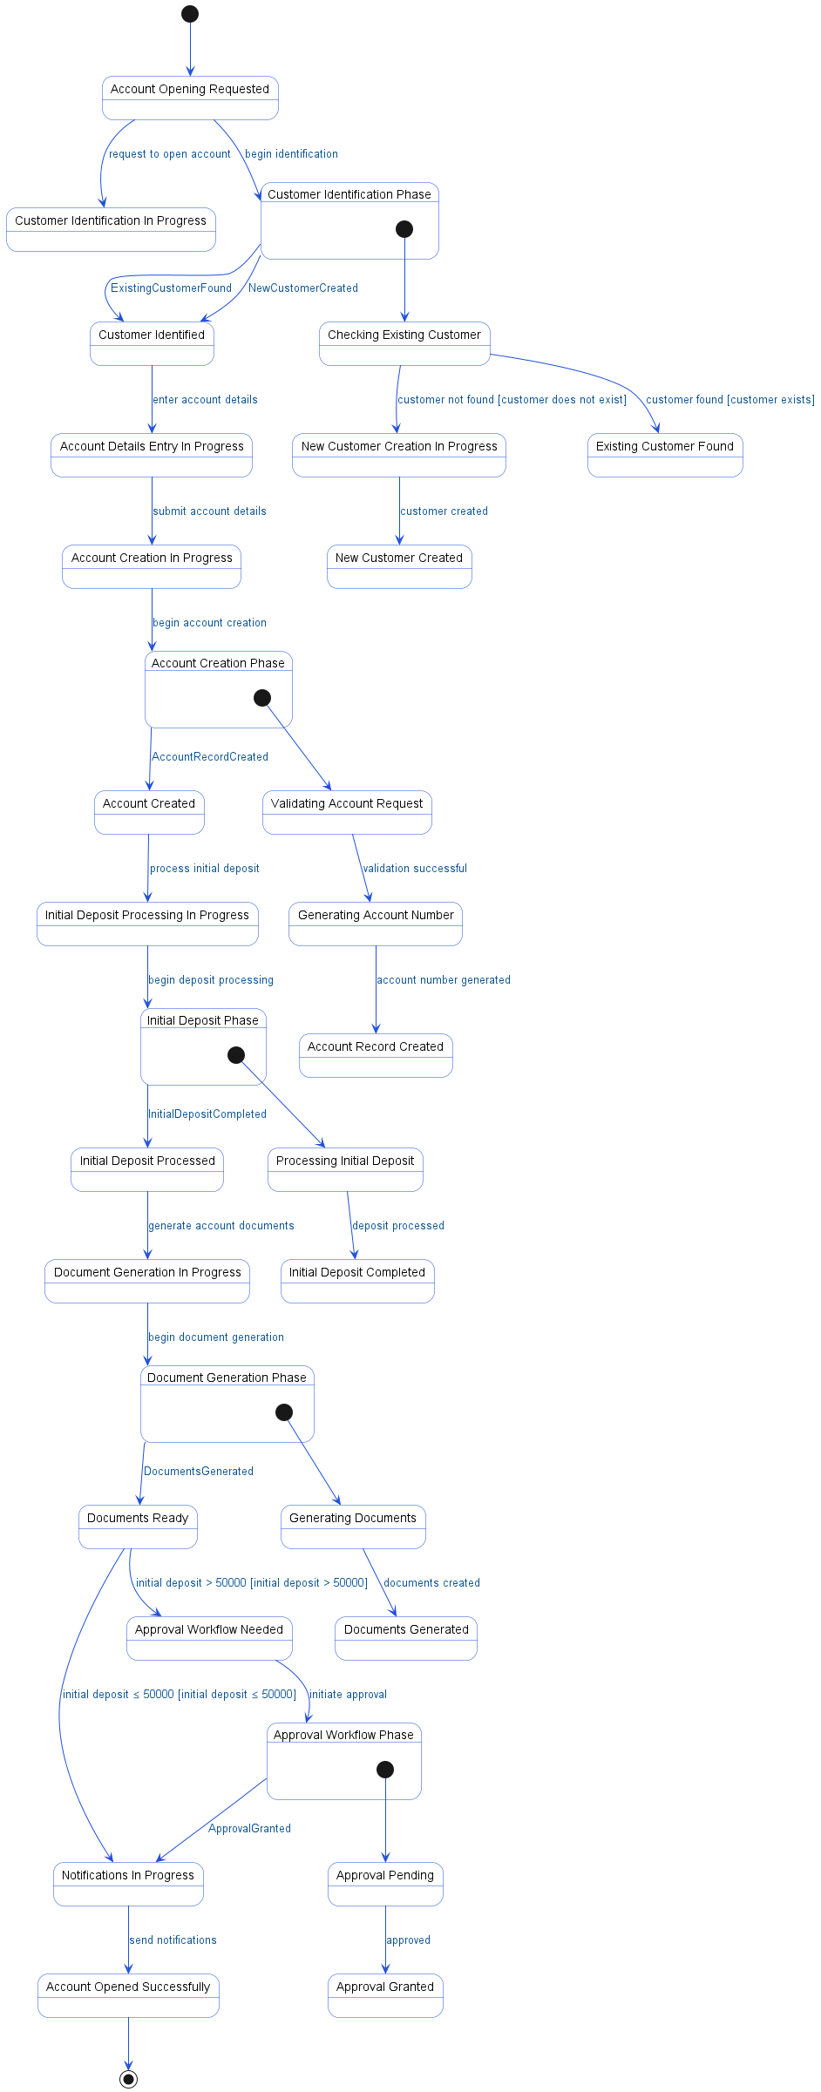

4.4. APIs Contract Agreement
# | Source | Destination | API | Protocol | Request Parameters | Response Parameters
1 | Branch System | API Gateway | GET /api/v1/customers/search?nationalId=xxx | REST |  | Customer found
2 | API Gateway | Customer Service | searchCustomer | REST | nationalId | {customer details}
3 | Branch System | API Gateway | POST /api/v1/customers | REST |  | Customer created
4 | API Gateway | Customer Service | createCustomer | REST | customerData | {customerId: C002}
5 | Branch System | API Gateway | POST /api/v1/accounts | REST |  | Account opened successfully
6 | API Gateway | Account Service | createAccount | REST | accountRequest | {accountNumber, status: ACTIVE}
7 | Account Service | Account DB | INSERT INTO accounts | JDBC |  | {accountId: ACC-001}
8 | Account Service | Account DB | UPDATE accounts SET balance = 5000 | JDBC
9 | Account Service | Account DB | INSERT INTO transactions | JDBC | CREDIT, CASH_DEPOSIT
10 | Account Service | GL Service | postEntry | REST | accountId, amount, type | {journalId: JE-001}
11 | Account Service | Document Service | generateAccountKit | REST | accountId | {documents: [...]}
12 | Account Service | Workflow Engine | initiateApproval | REST | accountId, amount | {workflowId, status: PENDING}
13 | Workflow Engine | Branch Officer | Approval notification | REST
14 | Workflow Engine | Account Service | approvalCallback | REST | approved
15 | Account Service | Notification Service | sendAccountOpened | REST | customerId, accountId
16 | Notification Service | Customer | SMS "Account SA01001... opened" | REST
17 | Notification Service | Customer | Email with account details | REST
[*] Indicates that the data element is optional

4.5. Error Handling
# | Source | Destination | Scenario | Handling
1 | API Gateway | Customer Service | searchCustomer  Timeout while waiting for customer search response from Customer Service | Retry up to 3 times with exponential backoff; Log error with correlation ID for traceability; Return error code to upstream caller
2 | API Gateway | Customer Service | searchCustomer  Customer Service unavailable during customer search request | Activate circuit breaker, use fallback response; Log error with correlation ID for traceability; Return error code to upstream caller; Notify operations team via alert if repeated
3 | API Gateway | Customer Service | searchCustomer  Customer not found in Customer Service | Return error code to upstream caller; Log error with correlation ID for traceability
4 | API Gateway | Customer Service | createCustomer  Timeout while waiting for createCustomer response from Customer Service | Ensure idempotency to avoid duplicates on retry; Retry up to 3 times with exponential backoff; Log error with correlation ID for traceability; Return error code to upstream caller
5 | API Gateway | Customer Service | createCustomer  Customer Service unavailable during createCustomer request | Ensure idempotency to avoid duplicates on retry; Activate circuit breaker, use fallback response; Log error with correlation ID for traceability; Notify operations team via alert if repeated
6 | API Gateway | Customer Service | createCustomer  Duplicate customer creation request received by Customer Service | Ensure idempotency to avoid duplicates on retry; Return error code to upstream caller; Log error with correlation ID for traceability
7 | API Gateway | Customer Service | createCustomer  Validation failure due to invalid or incomplete customer data | Return error code to upstream caller; Log error with correlation ID for traceability
8 | API Gateway | Account Service | createAccount  Timeout while waiting for createAccount response from Account Service | Ensure idempotency to avoid duplicates on retry; Retry up to 3 times with exponential backoff; Log error with correlation ID for traceability; Return error code to upstream caller
9 | API Gateway | Account Service | createAccount  Account Service unavailable during createAccount request | Ensure idempotency to avoid duplicates on retry; Activate circuit breaker, use fallback response; Log error with correlation ID for traceability; Notify operations team via alert if repeated
10 | API Gateway | Account Service | createAccount  Duplicate account creation request received by Account Service | Ensure idempotency to avoid duplicates on retry; Return error code to upstream caller; Log error with correlation ID for traceability
11 | API Gateway | Account Service | createAccount  Validation failure due to invalid account request data | Return error code to upstream caller; Log error with correlation ID for traceability
12 | Account Service | GL Service | postEntry  Timeout while waiting for postEntry response from GL Service | Ensure idempotency to avoid duplicates on retry; Retry up to 3 times with exponential backoff; Log error with correlation ID for traceability; Queue request for asynchronous retry
13 | Account Service | GL Service | postEntry  GL Service unavailable during postEntry request | Ensure idempotency to avoid duplicates on retry; Activate circuit breaker, use fallback response; Log error with correlation ID for traceability; Notify operations team via alert if repeated
14 | Account Service | GL Service | postEntry  Duplicate postEntry request received by GL Service | Ensure idempotency to avoid duplicates on retry; Log error with correlation ID for traceability
15 | Account Service | GL Service | postEntry  Validation failure due to invalid journal entry data | Return error code to upstream caller; Log error with correlation ID for traceability
16 | Account Service | Document Service | generateAccountKit  Timeout while waiting for generateAccountKit response from Document Service | Ensure idempotency to avoid duplicates on retry; Retry up to 3 times with exponential backoff; Log error with correlation ID for traceability; Queue request for asynchronous retry
17 | Account Service | Document Service | generateAccountKit  Document Service unavailable during generateAccountKit request | Ensure idempotency to avoid duplicates on retry; Activate circuit breaker, use fallback response; Log error with correlation ID for traceability; Notify operations team via alert if repeated
18 | Account Service | Document Service | generateAccountKit  Duplicate generateAccountKit request received by Document Service | Ensure idempotency to avoid duplicates on retry; Log error with correlation ID for traceability
19 | Account Service | Document Service | generateAccountKit  Validation failure due to missing or invalid accountId | Return error code to upstream caller; Log error with correlation ID for traceability
20 | Account Service | Workflow Engine | initiateApproval  Timeout while waiting for initiateApproval response from Workflow Engine | Ensure idempotency to avoid duplicates on retry; Retry up to 3 times with exponential backoff; Log error with correlation ID for traceability; Queue request for asynchronous retry
21 | Account Service | Workflow Engine | initiateApproval  Workflow Engine unavailable during initiateApproval request | Ensure idempotency to avoid duplicates on retry; Activate circuit breaker, use fallback response; Log error with correlation ID for traceability; Notify operations team via alert if repeated
22 | Account Service | Workflow Engine | initiateApproval  Duplicate initiateApproval request received by Workflow Engine | Ensure idempotency to avoid duplicates on retry; Log error with correlation ID for traceability
23 | Account Service | Workflow Engine | initiateApproval  Validation failure due to invalid approval data | Return error code to upstream caller; Log error with correlation ID for traceability
24 | Account Service | Notification Service | sendAccountOpened  Timeout while waiting for sendAccountOpened response from Notification Service | Ensure idempotency to avoid duplicates on retry; Retry up to 3 times with exponential backoff; Log error with correlation ID for traceability; Queue request for asynchronous retry
25 | Account Service | Notification Service | sendAccountOpened  Notification Service unavailable during sendAccountOpened request | Ensure idempotency to avoid duplicates on retry; Activate circuit breaker, use fallback response; Log error with correlation ID for traceability; Notify operations team via alert if repeated
26 | Account Service | Notification Service | sendAccountOpened  Duplicate sendAccountOpened request received by Notification Service | Ensure idempotency to avoid duplicates on retry; Log error with correlation ID for traceability
27 | Account Service | Notification Service | sendAccountOpened  Validation failure due to missing customerId or accountId | Return error code to upstream caller; Log error with correlation ID for traceability

5. Instant Fund Transfer via SARIE

5.1. Sequence Diagram
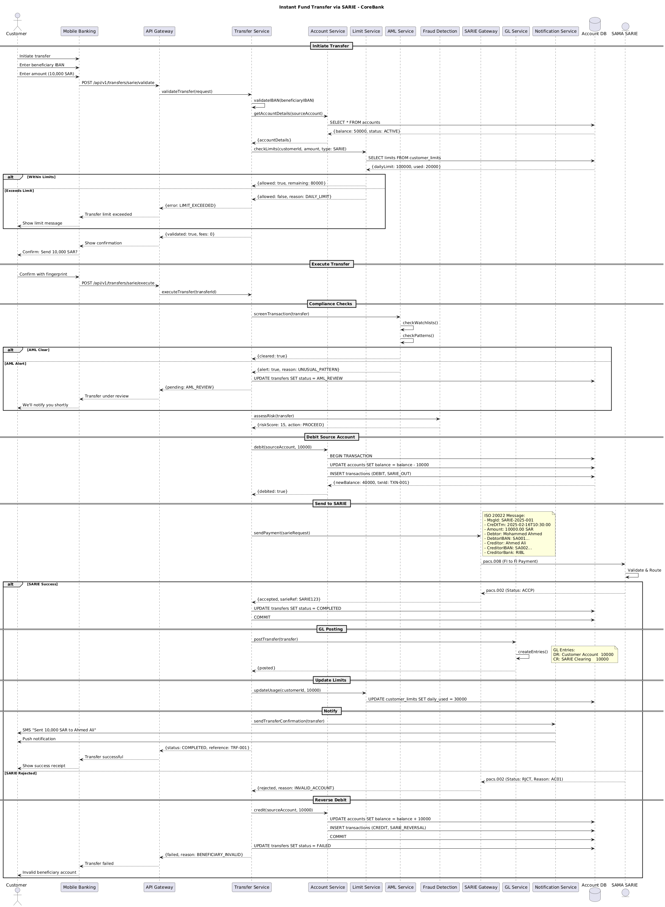

5.2. Flow Description
  - Overview
This flow describes the end-to-end process for executing an instant fund transfer via SARIE using the core banking system. The process involves the following actively participating components: Customer, Mobile Banking, API Gateway, Transfer Service, Account Service, Limit Service, AML Service, Fraud Detection, SARIE Gateway, SAMA SARIE, GL Service, Notification Service, and Account DB. Each participant is responsible for specific steps in the transfer lifecycle, including initiation, validation, compliance checks, transaction posting, and notification. The flow also covers all relevant conditional paths, including limit checks, compliance outcomes, SARIE response handling, and reversal logic.
  - Process Flow
Initiate Transfer
The process begins when Customer initiates a transfer request through Mobile Banking. Customer provides the beneficiary IBAN and specifies the transfer amount of 10,000 SAR. Mobile Banking then submits a validation request to API Gateway using the endpoint for SARIE transfer validation.
API Gateway forwards the validation request to Transfer Service. Transfer Service internally performs validateIBAN using the provided beneficiary IBAN. Transfer Service requests source account details from Account Service, which in turn queries Account DB for the account information. Account DB responds with the account balance and status. Account Service returns these account details to Transfer Service.
Next, Transfer Service requests a limit check from Limit Service for the customer, amount, and SARIE transfer type. Limit Service queries Account DB for the customer's transfer limits, and Account DB responds with the daily limit and the amount already used.
If the transfer amount is within the allowed limits, Limit Service returns an approval with the remaining limit to Transfer Service. Otherwise, if the limit is exceeded, Limit Service responds with a denial and the reason. In the case of a limit breach, Transfer Service returns an error to API Gateway, which informs Mobile Banking that the transfer limit has been exceeded. Mobile Banking then notifies Customer with a limit message.
If the transfer is validated successfully, Transfer Service returns a positive validation response with fee information to API Gateway. API Gateway instructs Mobile Banking to display a confirmation prompt to Customer, asking for confirmation to send 10,000 SAR.
Execute Transfer
Upon receiving the confirmation, Customer authenticates the transaction using a fingerprint in Mobile Banking. Mobile Banking submits the execution request to API Gateway, which forwards it to Transfer Service for processing.
Compliance Checks
Transfer Service initiates compliance screening by requesting AML Service to screen the transaction. AML Service internally performs checkWatchlists. AML Service then internally performs checkPatterns.
If the AML checks are clear, AML Service returns a cleared status to Transfer Service. If an AML alert is triggered, AML Service responds with an alert and the reason. In the event of an alert, Transfer Service updates the transfer status to AML_REVIEW in Account DB. Transfer Service then notifies API Gateway that the transfer is pending AML review. API Gateway informs Mobile Banking that the transfer is under review, and Mobile Banking notifies Customer that they will be updated shortly.
If the AML checks are cleared, Transfer Service requests Fraud Detection to assess the transaction risk. Fraud Detection returns a risk score and an action, indicating whether to proceed.
Debit Source Account
With compliance checks passed, Transfer Service instructs Account Service to debit the source account for 10,000 SAR. Account Service begins a transaction in Account DB, updates the account balance, and records the debit transaction for SARIE_OUT. Account DB responds with the new balance and transaction ID. Account Service confirms the debit to Transfer Service.
Send to SARIE
Transfer Service sends the payment request to SARIE Gateway using the SARIE request format.
Note: | ISO 20022 Message:
| - MsgId: SARIE-2025-001
| - CreDtTm: 2025-02-16T10:30:00
| - Amount: 10000.00 SAR
| - Debtor: Mohammed Ahmed
| - DebtorIBAN: SA001...
| - Creditor: Ahmed Ali
| - CreditorIBAN: SA002...
| - CreditorBank: RIBL
SARIE Gateway forwards the payment instruction to SAMA SARIE using the pacs.008 (FI to FI Payment) message. SAMA SARIE internally performs Validate & Route.
If SAMA SARIE accepts the transaction, it returns a pacs.002 message with acceptance status to SARIE Gateway, which relays the acceptance and SARIE reference to Transfer Service. Transfer Service updates the transfer status to COMPLETED in Account DB and commits the transaction.
GL Posting
Transfer Service posts the transaction to GL Service for general ledger entries. GL Service internally performs createEntries.
Note: | GL Entries:
| DR: Customer Account 10000
| CR: SARIE Clearing 10000
GL Service confirms the posting to Transfer Service.
Update Limits
Transfer Service instructs Limit Service to update the customer's usage by 10,000 SAR. Limit Service updates the daily used amount in Account DB.
Notify
Transfer Service notifies Notification Service to send a transfer confirmation. Notification Service sends an SMS to Customer stating that 10,000 SAR was sent to Ahmed Ali. Notification Service also sends a push notification. Transfer Service returns a completed status and reference to API Gateway. API Gateway informs Mobile Banking of the successful transfer, and Mobile Banking displays a success receipt to Customer.
If SAMA SARIE rejects the transaction, it returns a pacs.002 message with rejection status and reason to SARIE Gateway, which relays the rejection and reason to Transfer Service.
Reverse Debit
Upon rejection, Transfer Service instructs Account Service to credit the source account for 10,000 SAR. Account Service updates the account balance in Account DB, records a credit transaction for SARIE_REVERSAL, and commits the transaction. Transfer Service updates the transfer status to FAILED in Account DB. Transfer Service returns a failed status and reason to API Gateway, which informs Mobile Banking of the failure. Mobile Banking notifies Customer that the beneficiary account is invalid.
  - Authentication & Validation
• Transfer Service internally performs validateIBAN to ensure the beneficiary IBAN is valid.
• AML Service internally performs checkWatchlists() to screen the transaction against watchlists.
• AML Service internally performs checkPatterns() to detect unusual transaction patterns.
• SAMA SARIE internally performs Validate & Route to process and route the SARIE payment.
• GL Service internally performs createEntries() to generate the required general ledger entries for the transaction.

5.3. State Machine Diagram
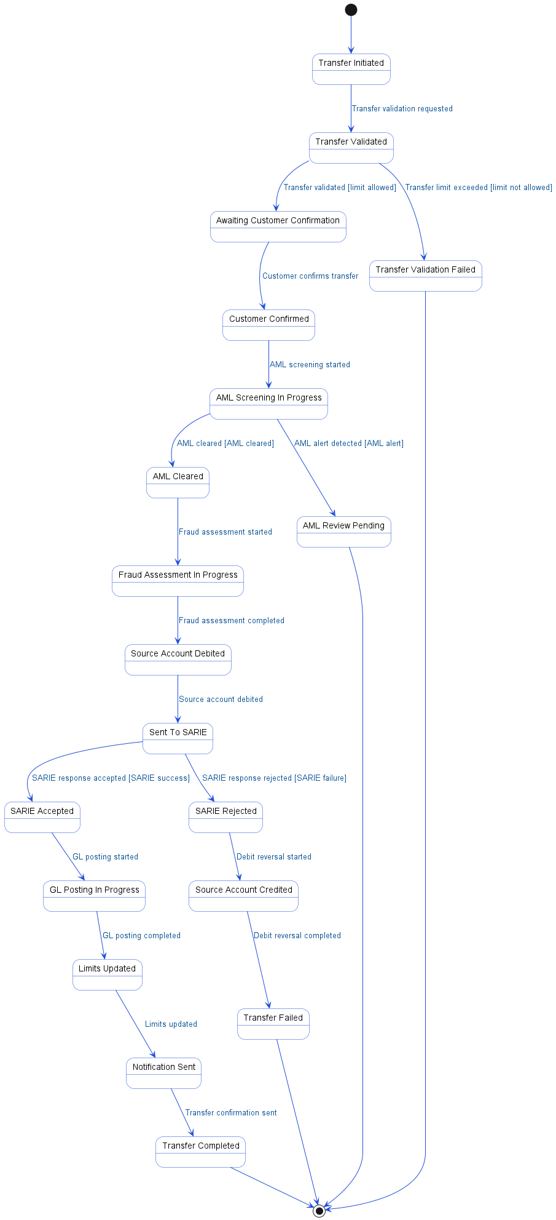

5.4. APIs Contract Agreement
# | Source | Destination | API | Protocol | Request Parameters | Response Parameters
1 | API Gateway | Transfer Service | validateTransfer | REST | request | {error: LIMIT_EXCEEDED}
2 | Transfer Service | Account Service | getAccountDetails | REST | sourceAccount | {accountDetails}
3 | Account Service | Account DB | SELECT * FROM accounts | JDBC |  | {balance: 50000, status: ACTIVE}
4 | Transfer Service | Limit Service | checkLimits | REST | customerId, amount, type: SARIE | {allowed: true, remaining: 80000}
5 | Limit Service | Account DB | SELECT limits FROM customer_limits | JDBC |  | {dailyLimit: 100000, used: 20000}
6 | API Gateway | Transfer Service | executeTransfer | REST | transferId | {pending: AML_REVIEW}
7 | Transfer Service | AML Service | screenTransaction | REST | transfer | {cleared: true}
8 | Transfer Service | Account DB | UPDATE transfers SET status = AML_REVIEW | JDBC
9 | Transfer Service | Fraud Detection | assessRisk | REST | transfer | {riskScore: 15, action: PROCEED}
10 | Transfer Service | Account Service | debit | REST | sourceAccount, 10000 | {debited: true}
11 | Account Service | Account DB | BEGIN TRANSACTION | JDBC |  | {newBalance: 40000, txnId: TXN-001}
12 | Account Service | Account DB | UPDATE accounts SET balance = balance - 10000 | JDBC
13 | Account Service | Account DB | INSERT transactions | JDBC | DEBIT, SARIE_OUT
14 | Transfer Service | SARIE Gateway | sendPayment | REST | sarieRequest | {accepted, sarieRef: SARIE123}
15 | SARIE Gateway | SAMA SARIE | pacs.008 | REST | FI to FI Payment | Status: ACCP
16 | Transfer Service | Account DB | UPDATE transfers SET status = COMPLETED | JDBC
17 | Transfer Service | Account DB | COMMIT | JDBC
18 | Transfer Service | GL Service | postTransfer | REST | transfer | {posted}
19 | Transfer Service | Limit Service | updateUsage | REST | customerId, 10000
20 | Limit Service | Account DB | UPDATE customer_limits SET daily_used = 30000 | JDBC
21 | Transfer Service | Notification Service | sendTransferConfirmation | REST | transfer
22 | Notification Service | Customer | SMS "Sent 10,000 SAR to Ahmed Ali" | REST
23 | Notification Service | Customer | Push notification | REST
24 | SAMA SARIE | SARIE Gateway | pacs.002 | REST |  | Status: RJCT, Reason: AC01
25 | Transfer Service | Account Service | credit | REST | sourceAccount, 10000
26 | Account Service | Account DB | UPDATE accounts SET balance = balance + 10000 | JDBC
27 | Account Service | Account DB | INSERT transactions | JDBC | CREDIT, SARIE_REVERSAL
28 | Account Service | Account DB | COMMIT | JDBC
29 | Transfer Service | Account DB | UPDATE transfers SET status = FAILED | JDBC
[*] Indicates that the data element is optional

5.5. Error Handling
# | Source | Destination | Scenario | Handling
1 | API Gateway | Transfer Service | validateTransfer  Transfer Service times out during validation request | Retry up to 3 times with exponential backoff; Log error with correlation ID for traceability; Return error code to upstream caller
2 | API Gateway | Transfer Service | executeTransfer  Transfer Service unavailable during transfer execution | Retry up to 3 times with exponential backoff; Log error with correlation ID for traceability; Return error code to upstream caller
3 | Transfer Service | Account Service | getAccountDetails  Account Service times out when retrieving account details | Retry up to 3 times with exponential backoff; Log error with correlation ID for traceability; Return error code to upstream caller
4 | Transfer Service | Account Service | getAccountDetails  Account not found for provided account identifier | Log error with correlation ID for traceability; Return error code to upstream caller
5 | Transfer Service | Limit Service | checkLimits  Limit Service unavailable during limit check | Retry up to 3 times with exponential backoff; Log error with correlation ID for traceability; Return error code to upstream caller
6 | Transfer Service | AML Service | screenTransaction  AML Service times out during screening | Retry up to 3 times with exponential backoff; Log error with correlation ID for traceability; Activate circuit breaker, use fallback response
7 | Transfer Service | Fraud Detection | assessRisk  Fraud Detection service unavailable during risk assessment | Retry up to 3 times with exponential backoff; Log error with correlation ID for traceability; Activate circuit breaker, use fallback response
8 | Transfer Service | Account Service | debit  Account Service times out during debit operation | Ensure idempotency to avoid duplicates on retry; Retry up to 3 times with exponential backoff; Log error with correlation ID for traceability; Notify operations team via alert if repeated
9 | Transfer Service | Account Service | debit  Insufficient funds detected during debit operation | Log error with correlation ID for traceability; Return error code to upstream caller
10 | Transfer Service | SARIE Gateway | sendPayment  SARIE Gateway times out during payment submission | Ensure idempotency to avoid duplicates on retry; Retry up to 3 times with exponential backoff; Log error with correlation ID for traceability; Notify operations team via alert if repeated
11 | Transfer Service | SARIE Gateway | sendPayment  SARIE Gateway unavailable during payment submission | Ensure idempotency to avoid duplicates on retry; Queue request for asynchronous retry; Log error with correlation ID for traceability; Notify operations team via alert if repeated
12 | Transfer Service | GL Service | postTransfer  GL Service times out during posting | Ensure idempotency to avoid duplicates on retry; Retry up to 3 times with exponential backoff; Log error with correlation ID for traceability; Notify operations team via alert if repeated
13 | Transfer Service | Limit Service | updateUsage  Limit Service unavailable during usage update | Retry up to 3 times with exponential backoff; Log error with correlation ID for traceability; Queue request for asynchronous retry
14 | Transfer Service | Notification Service | sendTransferConfirmation  Notification Service unavailable during confirmation send | Retry up to 3 times with exponential backoff; Log error with correlation ID for traceability; Queue request for asynchronous retry
15 | Transfer Service | Account Service | credit  Account Service times out during reversal credit operation | Ensure idempotency to avoid duplicates on retry; Retry up to 3 times with exponential backoff; Log error with correlation ID for traceability; Notify operations team via alert if repeated

6. Personal Loan Disbursement

6.1. Sequence Diagram
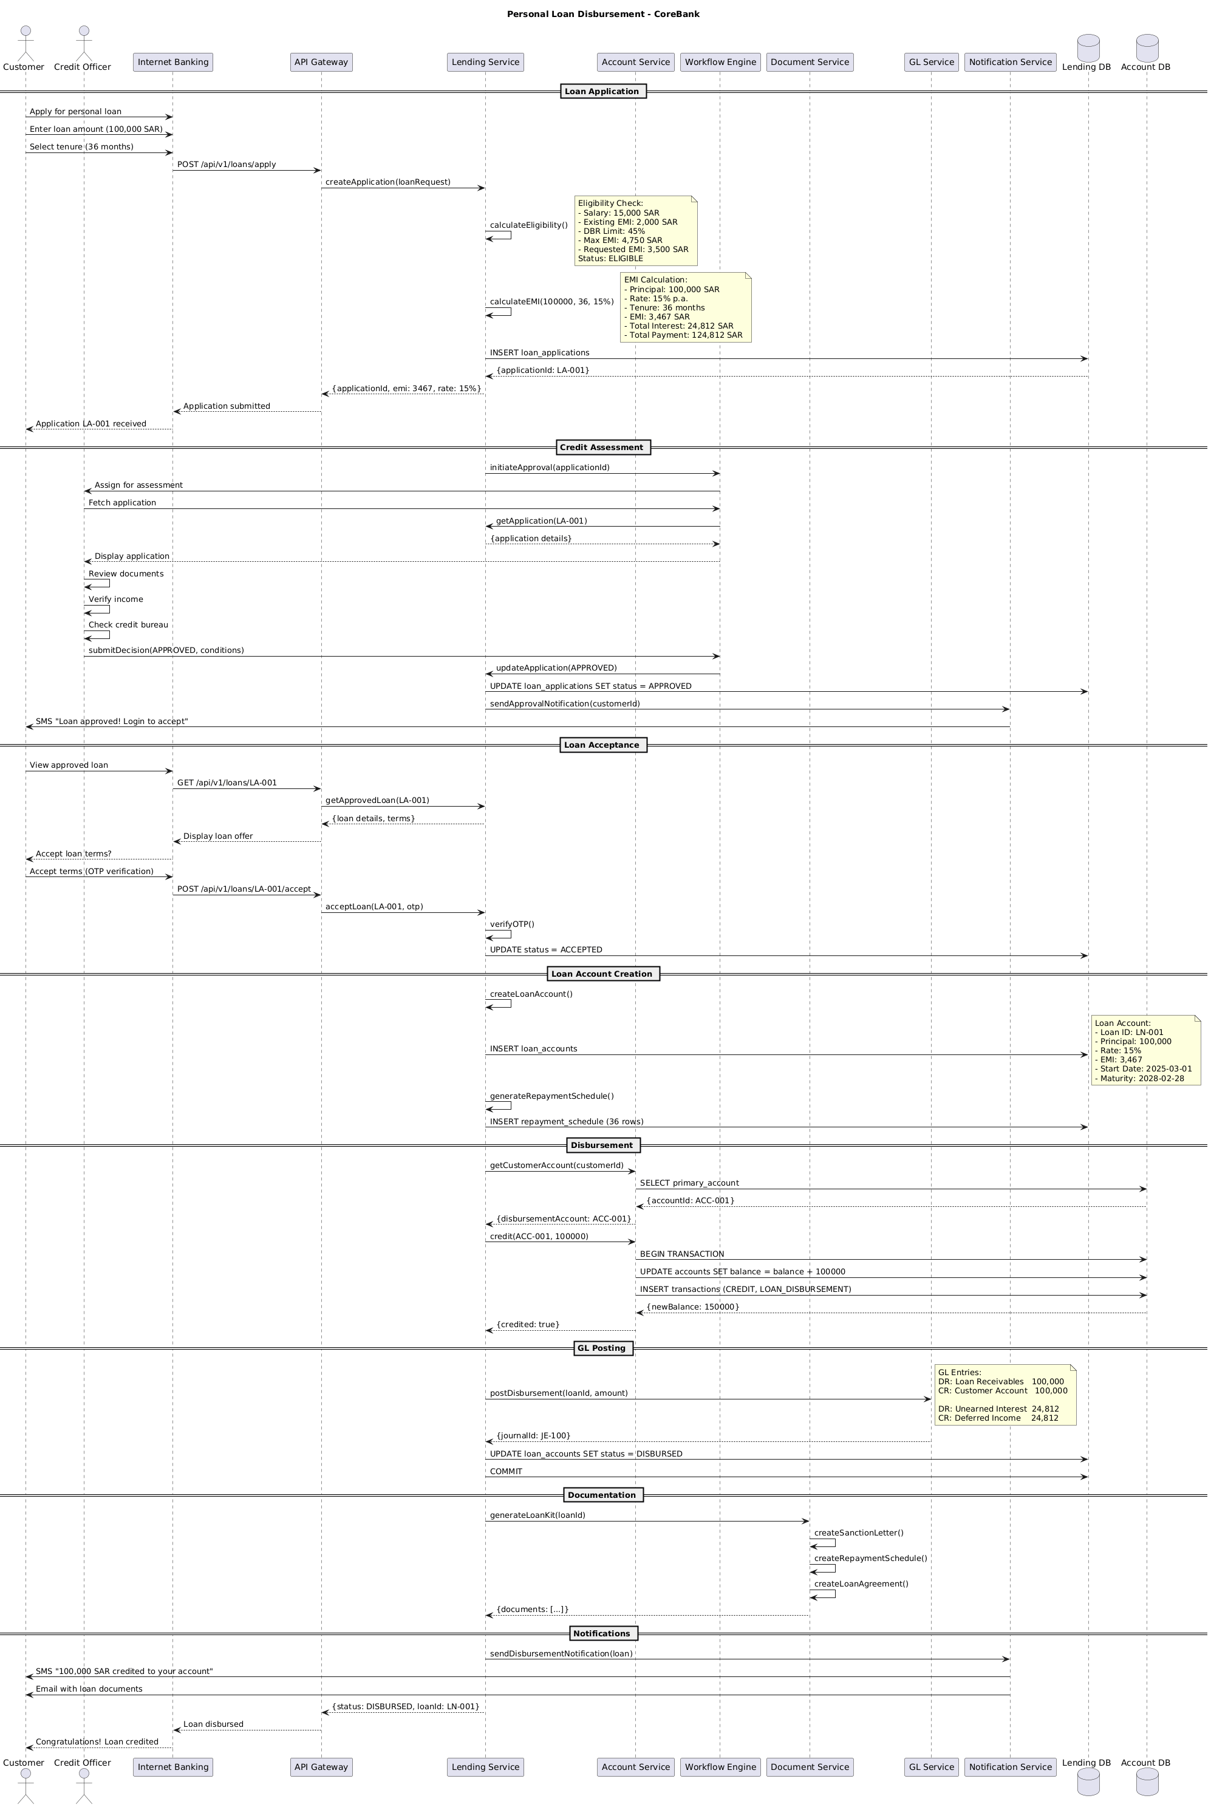

6.2. Flow Description
  - Overview
This flow describes the end-to-end process for personal loan disbursement in the CoreBank system. The process involves the following actively participating actors and systems: Customer, Credit Officer, Internet Banking, API Gateway, Lending Service, Account Service, Workflow Engine, Document Service, GL Service, Notification Service, Lending DB, and Account DB. The flow covers loan application initiation, eligibility and EMI calculation, credit assessment, customer acceptance, loan account creation, disbursement, general ledger posting, documentation, and customer notifications. Each participant is responsible for handling specific steps and interactions as detailed in the process flow.
  - Process Flow
Loan Application
The process begins when Customer interacts with Internet Banking to apply for a personal loan. Customer submits an application, enters the desired loan amount of 100,000 SAR, and selects a tenure of 36 months. Internet Banking forwards the application details to API Gateway using a POST request to the loan application endpoint. API Gateway relays the request to Lending Service to create a new loan application.
Lending Service internally performs an eligibility calculation.
Note: Eligibility Check:
- Salary: 15,000 SAR
- Existing EMI: 2,000 SAR
- DBR Limit: 45%
- Max EMI: 4,750 SAR
- Requested EMI: 3,500 SAR
Status: ELIGIBLE
Lending Service internally performs an EMI calculation using the parameters: 100,000 SAR principal, 36 months tenure, and a 15% annual rate.
Note: EMI Calculation:
- Principal: 100,000 SAR
- Rate: 15% p.a.
- Tenure: 36 months
- EMI: 3,467 SAR
- Total Interest: 24,812 SAR
- Total Payment: 124,812 SAR
Lending Service persists the application in Lending DB. Lending DB returns the generated application ID (LA-001). Lending Service responds to API Gateway with the application ID, calculated EMI, and interest rate. API Gateway confirms application submission to Internet Banking, which notifies Customer that application LA-001 has been received.
Credit Assessment
Lending Service initiates the approval workflow by notifying Workflow Engine with the application ID. Workflow Engine assigns the application to Credit Officer for assessment. Credit Officer requests the application details from Workflow Engine, which retrieves the information from Lending Service and displays it to Credit Officer.
Credit Officer internally reviews the documents. Credit Officer internally verifies the applicant's income. Credit Officer internally checks the applicant's credit bureau status. After completing the assessment, Credit Officer submits the decision (APPROVED, with any conditions) to Workflow Engine. Workflow Engine updates the application status in Lending Service. Lending Service updates the application status to APPROVED in Lending DB. Lending Service instructs Notification Service to send an approval notification to Customer, who receives an SMS indicating the loan has been approved and prompting login to accept.
Loan Acceptance
Customer logs in to Internet Banking to view the approved loan. Internet Banking requests the loan details from API Gateway, which fetches the approved loan information from Lending Service. API Gateway returns the loan details and terms to Internet Banking, which displays the offer to Customer and prompts for acceptance.
Customer accepts the loan terms, triggering an OTP verification process. Internet Banking submits the acceptance and OTP to API Gateway, which forwards the request to Lending Service for processing. Lending Service internally verifies the OTP. Upon successful verification, Lending Service updates the application status to ACCEPTED in Lending DB.
Loan Account Creation
Lending Service internally creates a new loan account. Lending Service inserts the loan account details into Lending DB.
Note: Loan Account:
- Loan ID: LN-001
- Principal: 100,000
- Rate: 15%
- EMI: 3,467
- Start Date: 2025-03-01
- Maturity: 2028-02-28
Lending Service internally generates the repayment schedule. Lending Service inserts the repayment schedule (36 rows) into Lending DB.
Disbursement
Lending Service requests the customer’s primary account from Account Service. Account Service queries Account DB for the primary account and returns account ID ACC-001 to Lending Service. Lending Service instructs Account Service to credit 100,000 SAR to account ACC-001.
Account Service begins a transaction in Account DB. Account Service updates the account balance by adding 100,000 SAR. Account Service inserts a transaction record for the credit and loan disbursement in Account DB. Account DB returns the new balance (150,000 SAR) to Account Service, which confirms the credit to Lending Service.
GL Posting
Lending Service instructs GL Service to post the disbursement for the loan ID and amount.
Note: GL Entries:
DR: Loan Receivables 100,000
CR: Customer Account 100,000
DR: Unearned Interest 24,812
CR: Deferred Income 24,812
GL Service returns the journal entry ID (JE-100) to Lending Service. Lending Service updates the loan account status to DISBURSED in Lending DB and commits the transaction.
Documentation
Lending Service requests Document Service to generate the loan kit for the loan ID. Document Service internally creates the sanction letter. Document Service internally creates the repayment schedule. Document Service internally creates the loan agreement. Document Service returns the generated documents to Lending Service.
Notifications
Lending Service instructs Notification Service to send a disbursement notification for the loan. Notification Service sends an SMS to Customer indicating that 100,000 SAR has been credited to the account. Notification Service also sends an email to Customer with the loan documents attached.
Finally, Lending Service returns the disbursement status and loan ID to API Gateway, which notifies Internet Banking that the loan has been disbursed. Internet Banking informs Customer with a congratulatory message confirming the loan credit.

6.3. State Machine Diagram
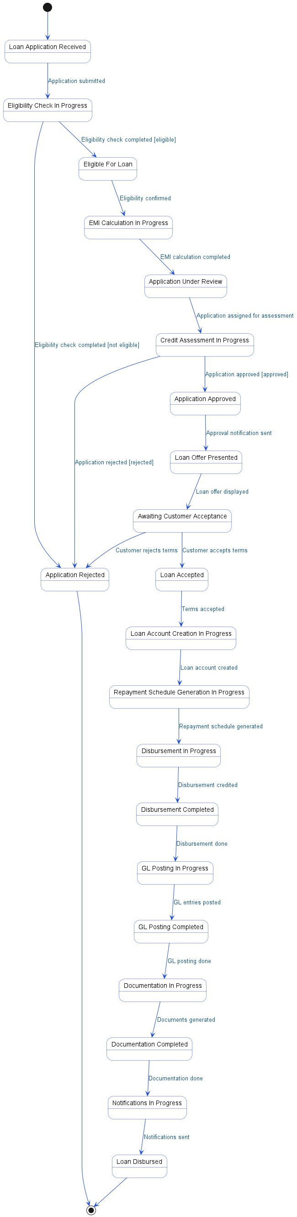

6.4. APIs Contract Agreement
# | Source | Destination | API | Protocol | Request Parameters | Response Parameters
1 | Internet Banking | API Gateway | POST /api/v1/loans/apply | REST |  | Application submitted
2 | API Gateway | Lending Service | createApplication | REST | loanRequest | {applicationId, emi: 3467, rate: 15%}
3 | Lending Service | Lending DB | INSERT loan_applications | JDBC |  | {applicationId: LA-001}
4 | Lending Service | Workflow Engine | initiateApproval | REST | applicationId
5 | Workflow Engine | Credit Officer | Assign for assessment | REST
6 | Workflow Engine | Lending Service | getApplication | REST | LA-001 | {application details}
7 | Workflow Engine | Lending Service | updateApplication | REST | APPROVED
8 | Lending Service | Lending DB | UPDATE loan_applications SET status = APPROVED | JDBC
9 | Lending Service | Notification Service | sendApprovalNotification | REST | customerId
10 | Notification Service | Customer | SMS "Loan approved! Login to accept" | REST
11 | Internet Banking | API Gateway | GET /api/v1/loans/LA-001 | REST |  | Display loan offer
12 | API Gateway | Lending Service | getApprovedLoan | REST | LA-001 | {loan details, terms}
13 | Internet Banking | API Gateway | POST /api/v1/loans/LA-001/accept | REST |  | Loan disbursed
14 | API Gateway | Lending Service | acceptLoan | REST | LA-001, otp | {status: DISBURSED, loanId: LN-001}
15 | Lending Service | Lending DB | UPDATE status = ACCEPTED | JDBC
16 | Lending Service | Lending DB | INSERT loan_accounts | JDBC
17 | Lending Service | Lending DB | INSERT repayment_schedule | JDBC | 36 rows
18 | Lending Service | Account Service | getCustomerAccount | REST | customerId | {disbursementAccount: ACC-001}
19 | Account Service | Account DB | SELECT primary_account | JDBC |  | {accountId: ACC-001}
20 | Lending Service | Account Service | credit | REST | ACC-001, 100000 | {credited: true}
21 | Account Service | Account DB | BEGIN TRANSACTION | JDBC |  | {newBalance: 150000}
22 | Account Service | Account DB | UPDATE accounts SET balance = balance + 100000 | JDBC
23 | Account Service | Account DB | INSERT transactions | JDBC | CREDIT, LOAN_DISBURSEMENT
24 | Lending Service | GL Service | postDisbursement | REST | loanId, amount | {journalId: JE-100}
25 | Lending Service | Lending DB | UPDATE loan_accounts SET status = DISBURSED | JDBC
26 | Lending Service | Lending DB | COMMIT | JDBC
27 | Lending Service | Document Service | generateLoanKit | REST | loanId | {documents: [...]}
28 | Lending Service | Notification Service | sendDisbursementNotification | REST | loan
29 | Notification Service | Customer | SMS "100,000 SAR credited to your account" | REST
30 | Notification Service | Customer | Email with loan documents | REST
[*] Indicates that the data element is optional

6.5. Error Handling
# | Source | Destination | Scenario | Handling
1 | API Gateway | Lending Service | createApplication  Timeout waiting for Lending Service response | Retry up to 3 times with exponential backoff; Log error with correlation ID for traceability; Return error code to upstream caller
2 | API Gateway | Lending Service | createApplication  Lending Service unavailable | Retry up to 3 times with exponential backoff; Log error with correlation ID for traceability; Activate circuit breaker, use fallback response
3 | Lending Service | Workflow Engine | initiateApproval  Workflow Engine unavailable | Retry up to 3 times with exponential backoff; Log error with correlation ID for traceability; Notify operations team via alert if repeated
4 | Workflow Engine | Lending Service | getApplication  Timeout waiting for Lending Service response | Retry up to 3 times with exponential backoff; Log error with correlation ID for traceability; Return error code to upstream caller
5 | Workflow Engine | Lending Service | getApplication  Application data not found | Return error code to upstream caller; Log error with correlation ID for traceability
6 | Workflow Engine | Lending Service | updateApplication  Timeout updating application status | Retry up to 3 times with exponential backoff; Log error with correlation ID for traceability; Return error code to upstream caller
7 | Workflow Engine | Lending Service | updateApplication  Lending Service unavailable | Retry up to 3 times with exponential backoff; Log error with correlation ID for traceability; Notify operations team via alert if repeated
8 | Lending Service | Notification Service | sendApprovalNotification  Notification Service unavailable | Retry up to 3 times with exponential backoff; Log error with correlation ID for traceability; Queue request for asynchronous retry
9 | API Gateway | Lending Service | getApprovedLoan  Timeout waiting for Lending Service response | Retry up to 3 times with exponential backoff; Log error with correlation ID for traceability; Return error code to upstream caller
10 | API Gateway | Lending Service | getApprovedLoan  Loan data not found | Return error code to upstream caller; Log error with correlation ID for traceability
11 | API Gateway | Lending Service | acceptLoan  Timeout waiting for Lending Service response | Retry up to 3 times with exponential backoff; Log error with correlation ID for traceability; Return error code to upstream caller
12 | API Gateway | Lending Service | acceptLoan  Lending Service unavailable | Retry up to 3 times with exponential backoff; Log error with correlation ID for traceability; Activate circuit breaker, use fallback response
13 | Lending Service | Account Service | getCustomerAccount  Timeout waiting for Account Service response | Retry up to 3 times with exponential backoff; Log error with correlation ID for traceability; Return error code to upstream caller
14 | Lending Service | Account Service | getCustomerAccount  Customer account not found | Return error code to upstream caller; Log error with correlation ID for traceability
15 | Lending Service | Account Service | credit  Timeout crediting customer account | Ensure idempotency to avoid duplicates on retry; Retry up to 3 times with exponential backoff; Log error with correlation ID for traceability; Rollback partial transaction
16 | Lending Service | Account Service | credit  Account Service unavailable | Ensure idempotency to avoid duplicates on retry; Retry up to 3 times with exponential backoff; Log error with correlation ID for traceability; Notify operations team via alert if repeated
17 | Lending Service | Account Service | credit  Duplicate credit request detected | Ensure idempotency to avoid duplicates on retry; Log error with correlation ID for traceability; Return error code to upstream caller
18 | Lending Service | Account Service | credit  Validation failure on account status or balance | Ensure idempotency to avoid duplicates on retry; Return error code to upstream caller; Log error with correlation ID for traceability
19 | Lending Service | GL Service | postDisbursement  Timeout posting to GL Service | Ensure idempotency to avoid duplicates on retry; Retry up to 3 times with exponential backoff; Log error with correlation ID for traceability; Rollback partial transaction
20 | Lending Service | GL Service | postDisbursement  GL Service unavailable | Ensure idempotency to avoid duplicates on retry; Retry up to 3 times with exponential backoff; Log error with correlation ID for traceability; Notify operations team via alert if repeated
21 | Lending Service | GL Service | postDisbursement  Duplicate GL posting request detected | Ensure idempotency to avoid duplicates on retry; Log error with correlation ID for traceability; Return error code to upstream caller
22 | Lending Service | GL Service | postDisbursement  Validation failure on GL entry data | Ensure idempotency to avoid duplicates on retry; Return error code to upstream caller; Log error with correlation ID for traceability
23 | Lending Service | Document Service | generateLoanKit  Timeout generating loan documents | Retry up to 3 times with exponential backoff; Log error with correlation ID for traceability; Return error code to upstream caller
24 | Lending Service | Document Service | generateLoanKit  Document Service unavailable | Retry up to 3 times with exponential backoff; Log error with correlation ID for traceability; Notify operations team via alert if repeated
25 | Lending Service | Notification Service | sendDisbursementNotification  Notification Service unavailable | Retry up to 3 times with exponential backoff; Log error with correlation ID for traceability; Queue request for asynchronous retry

7. Appendix

7.1. Account Opening Flow Data Elements
# | Service Name | Data Element | Description
1 | searchCustomer (Request) | nationalId | National identification number of the customer
2 | searchCustomer (Response) | customerId | Unique identifier for the customer
3 | searchCustomer (Response) | name | Full name of the customer
4 | createCustomer (Request) | customerData | Structured data containing new customer details
5 | createCustomer (Response) | customerId | Unique identifier for the newly created customer
6 | createAccount (Request) | customerId | Unique identifier for the customer
7 | createAccount (Request) | accountType | Type of account to be opened (e.g., SAVINGS)
8 | createAccount (Request) | currency | Currency code (e.g., SAR)
9 | createAccount (Request) | initialDeposit | Initial deposit amount for the new account
10 | createAccount (Request) | branchCode | Code identifying the branch where the account is opened
11 | createAccount (Response)  processInitialDeposit (Request)  postEntry (Request)  postEntry (Response)  generateAccountKit (Request)  generateAccountKit (Response)  initiateApproval (Request)  initiateApproval (Response)  approvalCallback (Request)  sendAccountOpened (Request) | accountId | Unique identifier for the newly created account
12 |  | amount | Transfer amount value for initial deposit
13 |  | accountId | Unique identifier for the account
14 |  | amount | Transfer amount value for GL entry
15 |  | type | Type of GL transaction (e.g., CREDIT, DEBIT)
16 |  | journalId | Unique identifier for the journal entry
17 |  | accountId | Unique identifier for the account
18 |  | documents | List of generated account documents
19 |  | accountId | Unique identifier for the account
20 |  | amount | Transfer amount value requiring approval
21 |  | workflowId | Unique identifier for the approval workflow
22 |  | status | Current transaction status (e.g., PENDING)
23 |  | approved | Approval status of the transaction
24 |  | customerId | Unique identifier for the customer
25 |  | accountId | Unique identifier for the account
26 |  | accountNumber | Generated account number for the new account
27 |  | status | Current transaction status (e.g., ACTIVE)

7.2. Instant Fund Transfer via SARIE Data Elements
# | Service Name | Data Element | Description
1 | validateTransfer (Request) | beneficiaryIBAN | International Bank Account Number of the beneficiary
2 | validateTransfer (Request) | sourceAccount | Customer's account number initiating the transfer
3 | validateTransfer (Request) | customerId | Customer Identification Code
4 | validateTransfer (Request) | amount | Transfer amount value
5 | validateTransfer (Response) | validated | Indicates if transfer validation passed
6 | validateTransfer (Response) | fees | Service fee amount charged
7 | validateTransfer (Response) | error | Error code or message if validation fails
8 | getAccountDetails (Request) | sourceAccount | Customer's account number initiating the transfer
9 | getAccountDetails (Response) | accountDetails | Full account information for the source account
10 | getAccountDetails (Response) | balance | Current account balance
11 | getAccountDetails (Response) | status | Current status of the account (e.g., ACTIVE)
12 | checkLimits (Request) | customerId | Customer Identification Code
13 | checkLimits (Request) | amount | Transfer amount value
14 | checkLimits (Request) | type | Transfer type (e.g., SARIE)
15 | checkLimits (Response) | dailyLimit | Customer's daily transfer limit
16 | checkLimits (Response) | used | Amount already used from daily limit
17 | checkLimits (Response) | allowed | Indicates if transfer is within allowed limits
18 | checkLimits (Response) | remaining | Remaining daily transfer limit
19 | checkLimits (Response) | reason | Reason for limit rejection (e.g., DAILY_LIMIT)
20 | executeTransfer (Request) | transferId | Unique identifier for the transfer request
21 | screenTransaction (Request) | transfer | Transfer object containing transaction details
22 | screenTransaction (Response) | cleared | Indicates if transaction passed AML checks
23 | screenTransaction (Response) | alert | Indicates if AML alert was triggered
24 | screenTransaction (Response) | reason | Reason for AML alert (e.g., UNUSUAL_PATTERN)
25 | screenTransaction (Response) | pending | AML review status (e.g., AML_REVIEW)
26 | assessRisk (Request) | transfer | Transfer object containing transaction details
27 | assessRisk (Response) | riskScore | Risk score assigned to the transaction
28 | assessRisk (Response) | action | Recommended action based on risk assessment
29 | debit (Request) | sourceAccount | Customer's account number to be debited
30 | debit (Request) | amount | Transfer amount value
31 | debit (Response) | newBalance | Account balance after debit
32 | debit (Response) | txnId | Transaction identifier for the debit
33 | debit (Response) | debited | Indicates if debit was successful
34 | sendPayment (Request) | sarieRequest | SARIE payment request object (ISO 20022 message)
35 | sendPayment (Request) | MsgId | Unique message identifier for SARIE transaction
36 | sendPayment (Request) | CreDtTm | Transaction timestamp
37 | sendPayment (Request) | Amount | Transfer amount value with currency
38 | sendPayment (Request) | Debtor | Name of the sender (debtor)
39 | sendPayment (Request) | DebtorIBAN | Sender's International Bank Account Number
40 | sendPayment (Request) | Creditor | Name of the beneficiary (creditor)
41 | sendPayment (Request) | CreditorIBAN | Beneficiary's International Bank Account Number
42 | sendPayment (Request) | CreditorBank | Bank identifier code for beneficiary's bank
43 | sendPayment (Response) | accepted | Indicates if SARIE accepted the payment
44 | sendPayment (Response) | sarieRef | Reference number assigned by SARIE
45 | sendPayment (Response) | rejected | Indicates if SARIE rejected the payment
46 | sendPayment (Response) | reason | Reason for SARIE rejection (e.g., INVALID_ACCOUNT)
47 | postTransfer (Request) | transfer | Transfer object containing transaction details
48 | postTransfer (Response) | posted | Indicates if GL posting was successful
49 | updateUsage (Request) | customerId | Customer Identification Code
50 | updateUsage (Request) | amount | Transfer amount value
51 | sendTransferConfirmation (Request) | transfer | Transfer object containing transaction details
52 | Transfer Result (Response) | status | Current transaction status
53 | Transfer Result (Response) | reference | Bank reference number for the transaction
54 | Transfer Result (Response) | failed | Indicates if the transfer failed
55 | Transfer Result (Response) | reason | Reason for transfer failure (e.g., BENEFICIARY_INVALID)

7.3. Personal Loan Disbursement Data Elements
# | Service Name | Data Element | Description
1 | createApplication (Request) | loanRequest | Loan application request object containing loan details
2 | createApplication (Response) | applicationId | Unique identifier for the loan application
3 | createApplication (Response) | emi | Calculated Equated Monthly Installment amount
4 | createApplication (Response) | rate | Interest rate applied to the loan
5 | initiateApproval (Request) | applicationId | Unique identifier for the loan application
6 | getApplication (Request) | applicationId | Unique identifier for the loan application
7 | getApplication (Response) | application details | Complete details of the loan application
8 | submitDecision (Request) | APPROVED | Approval status of the loan application
9 | submitDecision (Request) | conditions | Approval conditions, if any, for the loan
10 | updateApplication (Request) | APPROVED | Approval status to update in the application
11 | sendApprovalNotification (Request) | customerId | Unique identifier for the customer
12 | getApprovedLoan (Request) | applicationId | Unique identifier for the loan application
13 | getApprovedLoan (Response) | loan details | Approved loan details for the customer
14 | getApprovedLoan (Response) | terms | Terms and conditions of the approved loan
15 | acceptLoan (Request) | applicationId | Unique identifier for the loan application
16 | acceptLoan (Request) | otp | One-Time Password for verification
17 | getCustomerAccount (Request) | customerId | Unique identifier for the customer
18 | getCustomerAccount (Response) | disbursementAccount | Customer’s primary account for loan disbursement
19 | credit (Request) | ACC-001 | Account ID to be credited with loan amount
20 | credit (Request) | 100000 | Transfer amount value for loan disbursement
21 | credit (Response) | credited | Indicates if the account was successfully credited
22 | credit (Response) | newBalance | New account balance after crediting loan amount
23 | postDisbursement (Request) | loanId | Unique identifier for the loan account
24 | postDisbursement (Request) | amount | Transfer amount value for GL posting
25 | postDisbursement (Response) | journalId | Unique identifier for the GL journal entry
26 | generateLoanKit (Request) | loanId | Unique identifier for the loan account
27 | generateLoanKit (Response) | documents | List of generated loan documents
28 | sendDisbursementNotification (Request) | loan | Loan object containing disbursement details
29 | sendDisbursementNotification (Response) | status | Current transaction status
30 | sendDisbursementNotification (Response) | loanId | Unique identifier for the loan account

7.4. Solution Architecture Reference Documents
# | Name | File
1 | BRD | Refer to Latest BRD Attached to JIRA Ticket

